AIM

To design and deploy a cloud-based Library Book Reservation System for the SIMATS Library using Zoho Creator, thereby demonstrating the concept of Software as a Service (SaaS).

PROCEDURE

- Login to Zoho Creator using your Zoho account.
- Create a new application → Select “Create from Scratch.”
- Name the Application: SIMATS Library Reservation System.
  - Design Forms: Book Details Form (Admin use): Book ID, Title, Author, Department, Availability (Yes/No).
  - Student Reservation Form: Student Name, Register Number, Email, Book Selection (lookup from Book Details), Reservation Date.

  - Create Reports: Available Books Report → Displays list of books with status.
  - Reservation Report → Shows which student reserved which book.

  - Workflow Automation (Optional): Send a confirmation email to the student when a reservation is placed.
  - Notify librarian when a book is reserved.

- Publish the Application → Share link with SIMATS students.
- Test the Application by making a sample reservation as a student

OUTPUT

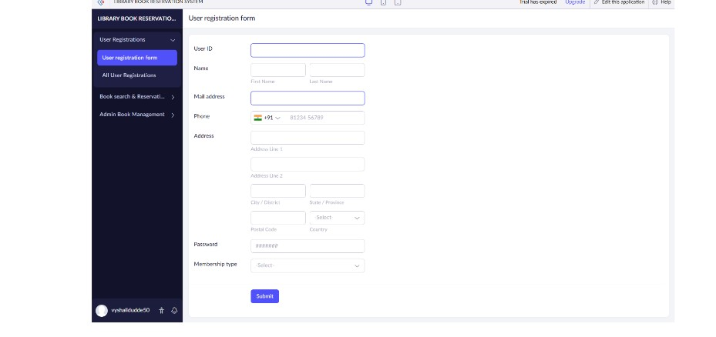
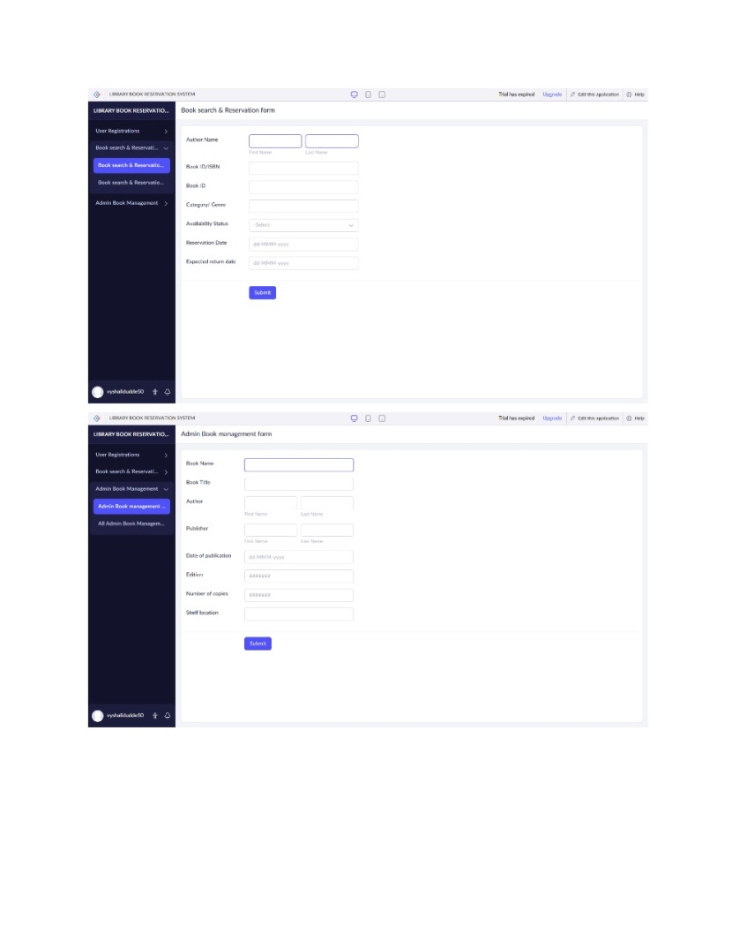
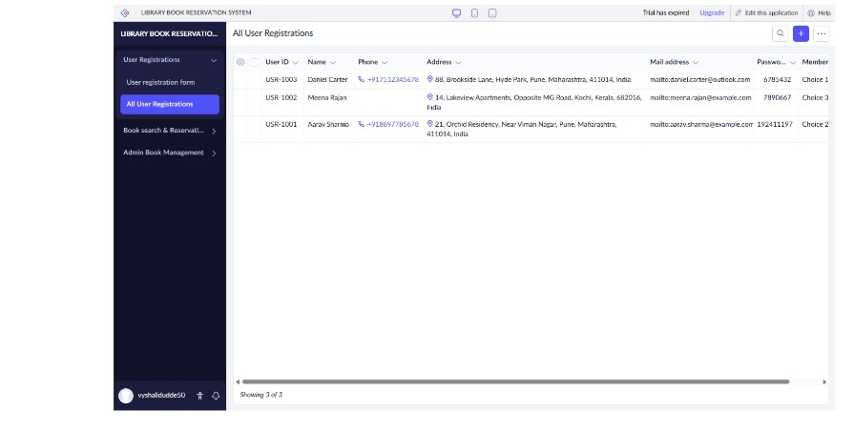
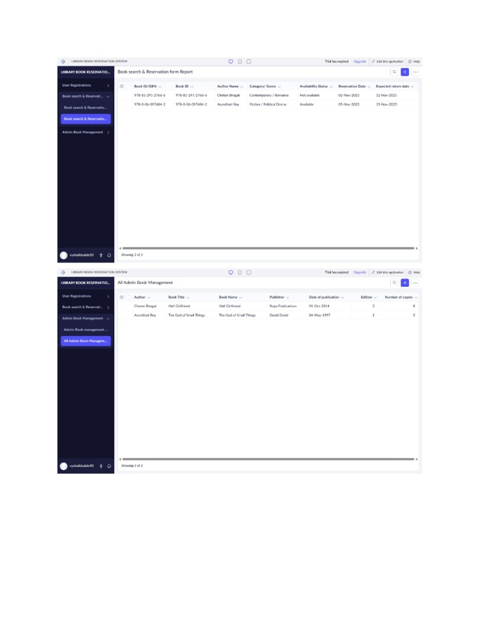
RESULT
Thus, the Library Book Reservation System is implemented using Zoho software

